Place Value Chart

International System
The place value chart of the International System is given below:
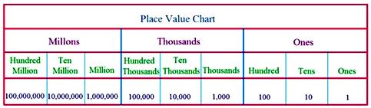
100,000 = 100 thousand
1,000,000 = 1 million
10,000,000 = 10 millions
100,000,000 = 100 millions
Whole numbers can be represented on the place-value chart.
The numbers 702845 and 360400295 are represented on the place-value chart.
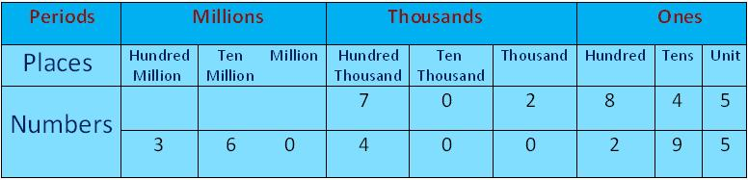
We can expand these numbers as:
702845 = 7 × 100000 + 2 × 1000 + 8 × 100 + 4 × 10 + 5 × 1
360400295 = 3 × 100000000 + 6 × 10000000 + 4 × 100000 + 2 × 100 + 9 × 10 + 5 × 1
In 702845:
Place value of 7 is 7 × 100000 = 700000 and the place is hundred thousand.
Place value of 2 is 2 × 1000 = 2000 and the place is thousands.
Place value of 8 is 8 × 100 = 800 and the place is hundreds.
Place value of 4 is 4 × 10 = 40 and the place is tens.
Place value of 5 is 5 × 1 = 5 and the place is ones.
In 360400295:
Place value of 3 is 3 × 100000000 = 300000000 and the place is hundred million.
Place value of 6 is 6 × 10000000 = 60000000 and the place is ten million.
Place value of 4 is 4 × 100000 = 400000 and the place is hundred thousand.
Place value of 2 is 2 × 100 = 200 and the place is hundred.
Place value of 9 is 9 × 10 = 90 and the place is tens.
Place value of 5 is 5 × 1 = 5 and the place is ones.
Note:
The place value of digit 0 at any place is 0.
Let’s read the numbers by observing the place value chart;
218705 – The number is read as 218 thousands 705.
It is written as 218,705 (using comma).
42156 – The number is read as 42 thousands 156.
It is written as 42,156 (using comma).
25374821 – The number is read as 25 million 374 thousands 821.
It is written as 25,374,821 (using comma).

